Firefly for Parent app
Activating the app
Download the app from the Google play store (Android) or Apple app store (iOS)
When you launch the app you will be presented with this screen:

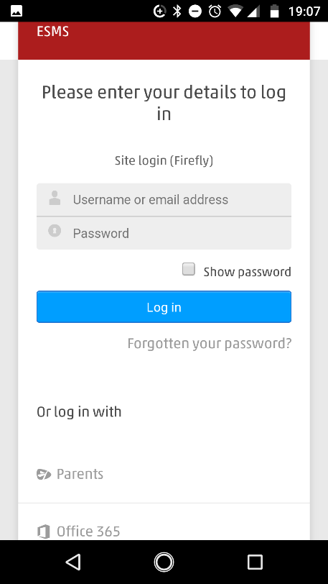
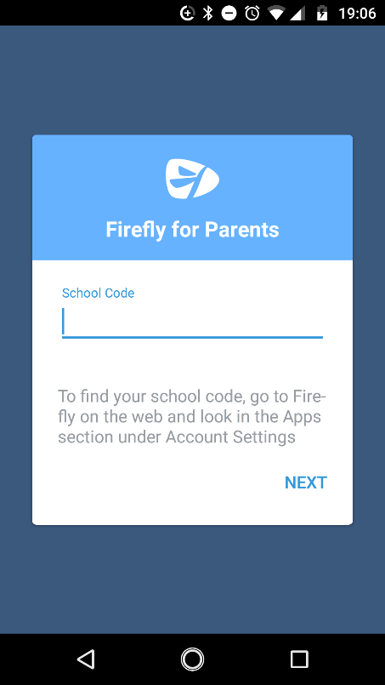
Once you have entered the school code ESMS

you will be taken to a screen that asks you to log in

Towards the bottom of that page it will say:

Or Log in with
Parents
Office 365

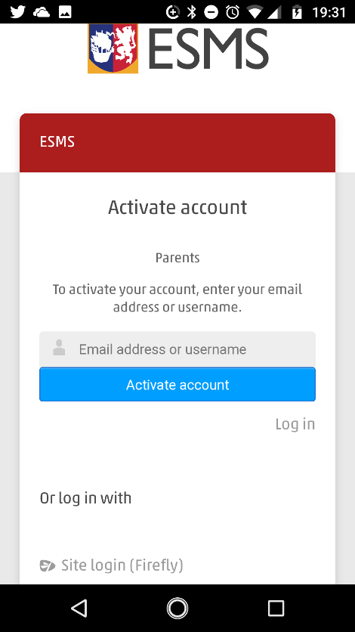
Click on Parents and you will be taken to another page that looks identical but has a green box with Logging in for the first time? Activate your account
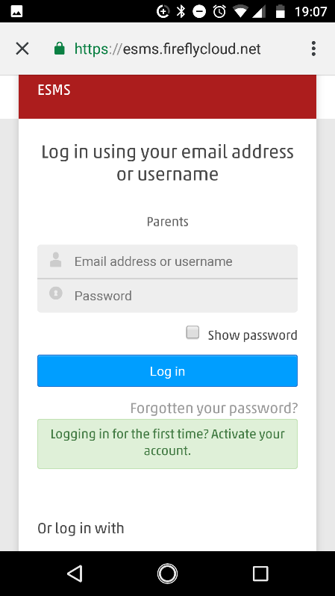
Click on the box and you will be redirected to a page that says to activate your account, enter your email address or username

If you then enter the email address that the school sends School Posts to then click Activate account it will inform you that it has sent you an email

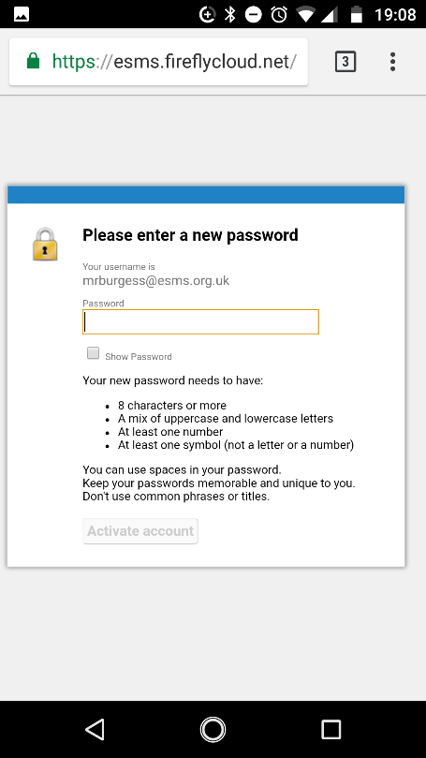
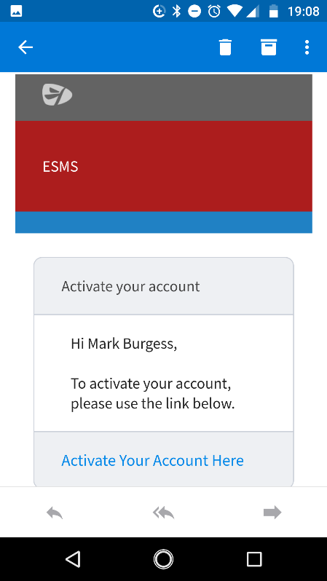
You should then receive an email which has an Activate your account here in blue
Clicking here will redirect you to another screen that will ask you to create a password and give you the information about what the password needs to contain and then an option to activate account.
This password does not need to be the same as the My ESMS password as the requirements may be different

When you now open the app you should be presented with this screen again
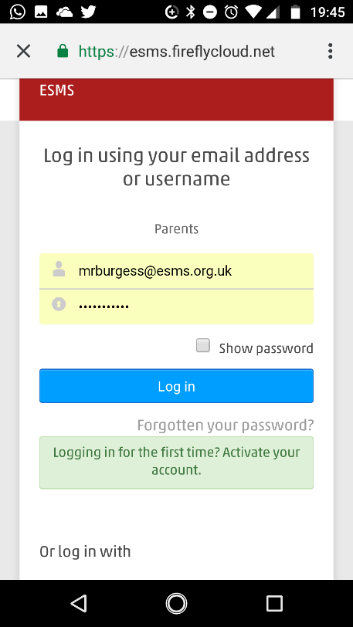
Click on Parents again and log in with your details (if they are not already saved)

This will then access the app and you should be presented with the following screen

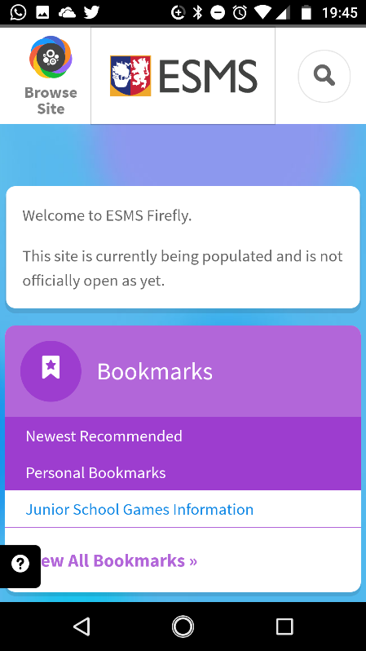
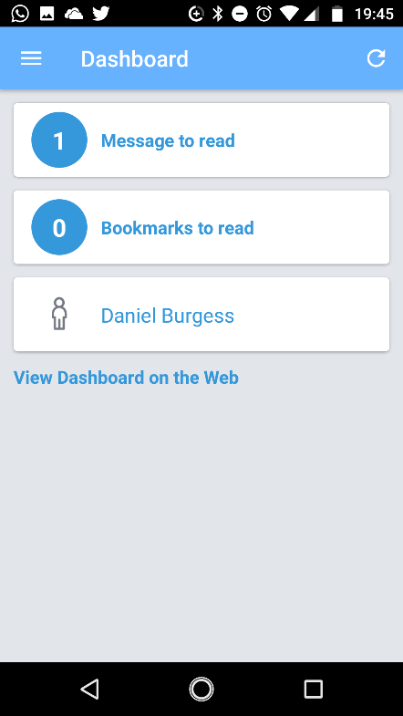
Any messages or recommend bookmarks will appear here and you can access you child’s profile

Clicking on View Dashboard on the Web will access the normal Firefly website.

Firefly are very helpful and usually respond to any support questions within an hour. They are available on support@fireflylearning.com

